FY2018 SPECTRIM Application Portfolio Management
Instructions
Guidance for Texas State Agencies
Instructions updated, January 24, 2018

Texas Department of Information Resources

Contents
Overview 3
Background 3
Purpose 3
Definitions 3
Sensitive Information 3
General Instructions 4
Organization 4
Accessing SPECTRIM Portal 4
Accessing the APM Tool 4
Submission 5
Additional Information 5
Part 1: Business Application Validation 6
Business Application Validation Instructions 6
Adding Business Applications 8
Removing Business Applications 9
Attestation 9
Part 2: APM Assessment 11
Parts 3 – 6 13
General Instructions 13
Accessing 13
Part 3: Architecture Section 14
Part 4: Business Section 16
Part 5: Financial Section 23
Part 6: Technical Section 25
Glossary 33

Overview

Background
Recently, DIR launched the SPECTRIM module “Application Portfolio Management (APM)” in a joint effort involving the Information Resources Deployment Review (IRDR) and the Prioritization of Cybersecurity and Legacy Modernization Projects (PCLS). You should have received a system-generated email notification on November 9th, 2017 with instructions for completing the Business Application Validation and Business Application Assessment processes from noreply@rsa.com.
The FY18 IRDR and SB1 Rider 9.10 Prioritization of Cybersecurity and Legacy Systems will depend on information specific to agencies’ Business Applications. This assessment process is used to inform and provide baseline data for both activities.

Purpose
The SPECTRIM Application Portfolio Management (APM) tool provides agencies with the ability to validate that Business Applications are documented in SPECTRIM and complete questionnaires on each Business Application.
Currently in the SPECTRIM portal, there are Business Applications associated with each organization. To ensure that the information associated with each agency is current and accurate, we are requesting that agencies validate their Business Applications.
This information will be used to launch application assessments for each Business Application, as well as to populate fields for future reporting requirements, e.g. the Information Resources Deployment Review (IRDR) and the Prioritization of Cybersecurity and Legacy Systems (PCLS). The validation process will occur between November 2017 and January 2, 2018. Please send all inquiries about the validation process to pcls@dir.texas.gov.

Definitions
Definitions of technical terms used in this document are provided in the glossary.

Sensitive Information
The information submitted by your agency to the Department of Information Resources is subject to the Texas Public Information Act. The Department believes portions of the information from this assessment to be confidential, and therefore, the Department will seek to withhold this information if a public information request in received. You must follow the portal’s instructions and mark printed materials from this system according to your organization's classification/confidentiality requirements.

General Instructions

Organization
The SPECTRIM APM instructions below are organized as follows:
- Part 1: Business Application Validation provides preparation of agency Business Application entries to support the IRDR and PCLS

- Part 2: APM Assessment provides general information about the agency’s Business Application and personnel responsible for submitting information in questionnaires.

- Part 3: Architecture Section Key attributes targeted at understanding the inventory configuration including technology vendors and implementation style

- Part 4: Business Section Key indicators targeted at understanding value and usage from an end-user or business manager perspective

- Part 5: Financial Section Key indicators targeted at understanding the ongoing costs (excluding upfront costs) from a business or technical manager perspective

- Part 6: Technical Section Key indicators targeted at understanding the technology effectiveness from a technical manager or architecture perspective

Accessing SPECTRIM Portal
To access the SPECTRIM portal, navigate to the following URL and enter the appropriate credentials: Note: All login fields must be typed in – the SPECTRIM system does not support copy/paste for these login fields.
How to sign into SPECTRIM:
- Navigate to https://grc.archer.rsa.com and login.
- User Name: This will be your agency email address.
- Instance: Enter “20224” in this field.
- Password: The first time you enter the system you will enter your temporary password that was sent to you via email. You will then be prompted to change your password. Please set a strong password for this account. To request a PW reset send inquiry to grc@dir.texas.gov
If the IRM would like to assign an APM Coordinator, Assessor or Reviewer that is not currently an active user in the SPECTRIM portal, please send an inquiry to grc@dir.texas.gov requesting access for those users. The IRM will need to provide the written authorization for any additional users, users cannot self-request.

Accessing the APM Tool
To get to the APM tool, select the APM module in the top banner, which will bring you to the APM Assessment Dashboard.
If you do not see the APM module in the top banner, click the SHOW ALL button, and select APM from the left-hand menu, then select Application Portfolio Management Assessment from the Dashboards list.
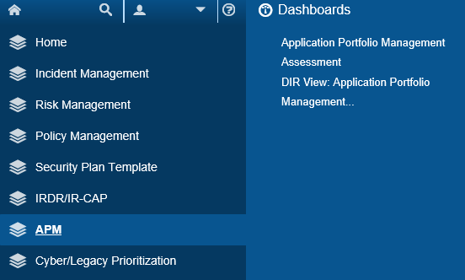
Data can be entered in multiple sessions from multiple computers, but individual records cannot be edited simultaneously. All data entered is saved in a central database and may be viewed and updated in future sessions. Please send an email to grc@dir.texas.gov if you have any questions about navigating or accessing the SPECTRIM system.

Submission
APM submissions are completed via the SPECTRIM tool, no signature or hardcopy submission is available. Each APM Coordinator is responsible for coordinating the APM assessment and review process within the agency and ensuring that the APM assessments are completed.

Additional Information
Additional resources and instructions for completing the APM Business Application Validation and Assessment processes can be found on the DIR website: http://dir.texas.gov/View-Resources/Pages/Content.aspx?id=29
DIR staff is committed to providing support to agencies. DIR staff will strive to answer all inquiries within two business days. Agencies are encouraged to submit inquiries whenever they do not understand a question or are uncertain how to respond to it.
- Please send all inquiries regarding content and process to pcls@dir.texas.gov.
- Please send all inquiries regarding the SPECTRIM portal and technical assistance to grc@dir.texas.gov.

Part 1: Business Application Validation
The responsibility for validating the agency’s applications are accurate lies with the agency’s Information Resources Manager (IRM). The IRM will need to review the following fields for accuracy and determine the status of the Business Application (active/inactive). Additionally, the IRM should add any new Business Applications not listed and complete the associated fields.
Information System Name: Business Application Name
Business Application Long Name: Full name of the application, no acronyms
Application Description: A brief one or two paragraph description of the application's purpose
Mission Critical: Values will be Yes or No. This value is determined by the agency's internal view of an application's relative business criticality.
APM Coordinator: An agency individual assigned to coordinate the assessment of that Business Application after the "App Validation" field is marked "Complete.” (Different agency staff may be assigned as APM Coordinators for the agency’s various Business Applications.)
Status: Agency determines whether the Business Application is currently in use. If an application is no longer used, mark it “Inactive”. This will prevent an APM assessment from generating for the application.
App Validation: Agency should select 'In Process', 'Complete' or 'Not Started' to indicate the validation status for each Application.

Business Application Validation Instructions

URL
Agencies may use the following URL to directly navigate to the Application Validation Page: https://grc.archer.rsa.com/default.aspx?requestUrl=..%2fSearchContent%2fSearch.aspx%3fView%3dReport%26reportId%3d6372%26moduleId%3d70

Browsing
To get to the Application Validation section from within SPECTRIM:
- From the Dashboard, locate the APM Reports pane (in the middle right-hand corner of the webpage) and select the hyperlink titled “My Organization’s Applications – Ready for Validation”.
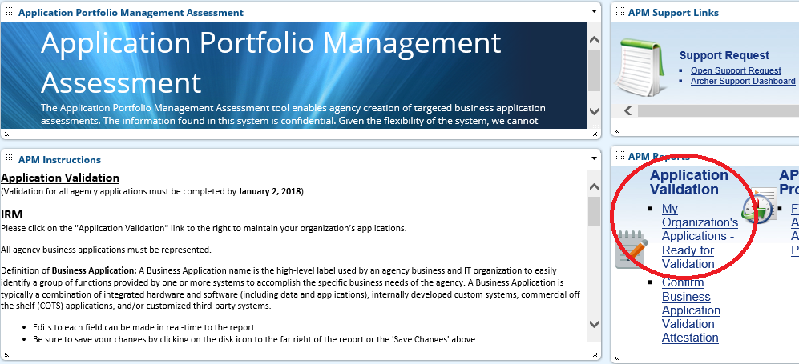
- Selecting the hyperlink will take you to the inline edit page for application validation. This page will have a list of all the Business Applications currently associated with the agency in the SPECTRIM Portal.

Instructions
The IRM will need to update the fields for each application directly on this page (do not enter the individual applications by selecting the ID hyperlink).
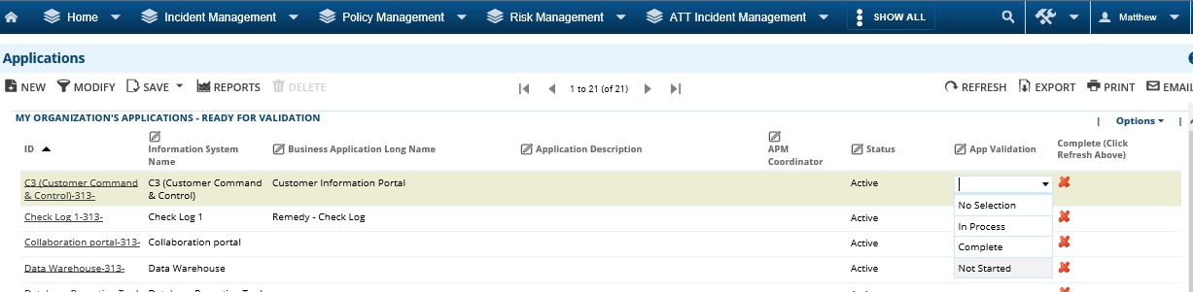
Simply click on the field you would like to update, enter any changes or additional information, and select the “save icon” () at the far right of the row to save your changes (icon will not appear until changes to a field have been made). This will save any changes you made to a single line (application). If you would like to save the changes globally, you may select the “Save Changes” option that appears in the upper-right hand corner of SPECTRIM after any changes are made to a record. After finishing and saving all the changes, click the refresh button in the upper-right corner to verify that the application has been marked as “Complete”.
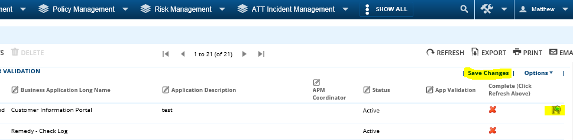
Once a Business Application validation is marked “Complete” an APM Assessment for that Business Application will be automatically generated and an email notification sent to the identified APM Coordinator.

Adding Business Applications
If the IRM needs to add a new application to the list, click the New button in the upper left-hand corner. This will take the IRM to a new screen to create the application.
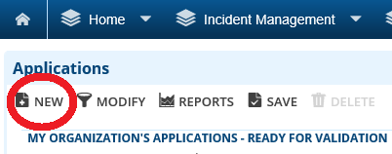
Fill out the mandatory fields, click Save in the upper left-hand corner, then close the application window via the X icon in the upper right-hand corner.
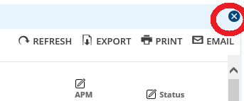

Removing Business Applications
If an application is listed that is no longer used by the agency, please do not delete the application. Instead, change the status to “Inactive”. Setting the status to “Inactive” will prevent the APM tool from requiring an assessment for the application.

Attestation
When all the agency’s Business Applications have been validated, the IRM will be responsible for confirming that all Business Applications currently in use have been added/updated in SPECTRIM.
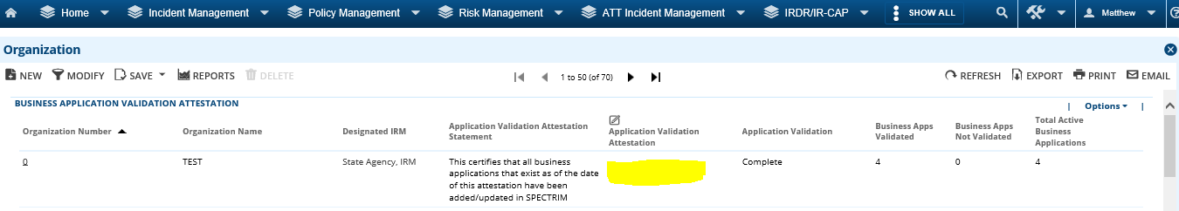
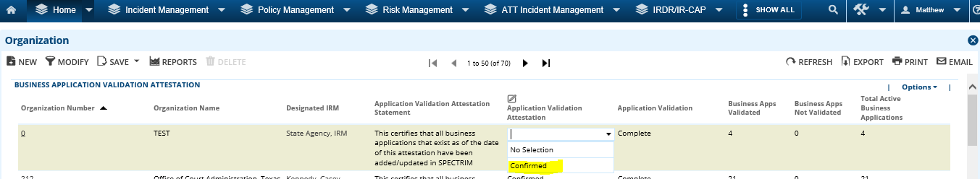

Shortcut
The attestation can be reached through the following URL: https://grc.archer.rsa.com/default.aspx?requestUrl=..%2fSearchContent%2fSearch.aspx%3fView%3dReport%26reportId%3d6377%26moduleId%3d192

Browsing
To get to the Application Attestation from within SPECTRIM, from the Dashboard, locate the APM Reports pane (in the middle right-hand corner of the webpage) and select the hyperlink titled “Confirm Business Application Validation Attestation”.
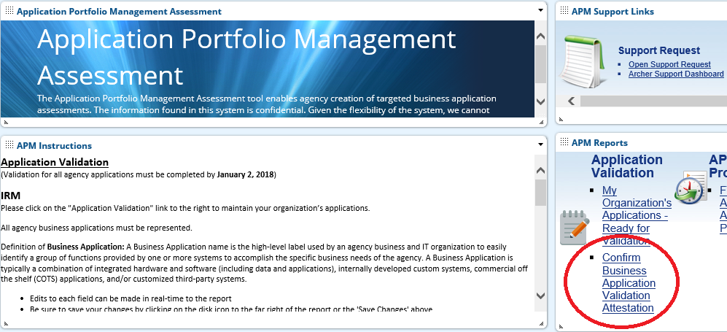

Part 2: APM Assessment
Once all the required fields for an application have been updated and the validation status changed to “complete,” the system will notify the APM Coordinator of that application that they may begin assigning assessors and reviewers. Please note that the assessment process must be completed for all Business Applications by March 31st, 2018.
Once in the APM Assessment window, the following information must be filled out and saved.
APM Assessment Name <Enter text response>

Business Application ID <Choose Business Application>

Organization <Choose Agency Name>

APM Coordinator <Auto Populated from the related Business Application (can be changed by IRM)>

Due Date <Auto Populated to 45 days from the creation date>

Architecture Assessor <Choose One Assessor to complete questionnaire>

Architecture Reviewer(s) <Choose Up to Three Reviewer(s) to review questionnaire>

Business Assessor(s) <Choose Up to Three Assessor(s) to complete questionnaire>

Business Reviewer(s) <Choose Up to Three Reviewer(s) to review questionnaire>

Financial Assessor <Choose One Assessor to complete questionnaire>

Financial Reviewer(s) <Choose Up to Three Reviewer(s) to review questionnaire>

Technical Assessor(s) <Choose Up to Three Assessor(s) to complete questionnaire>

Technical Reviewer(s) <Choose Up to Three Reviewer(s) to review questionnaire>

Launch Architecture Section <Choose Yes when ready to create questionnaires>

Architecture Section Launch Date <Choose future Date to launch questionnaires>

Launch Business Section <Choose Yes when ready to create questionnaires>

Business Section Launch Date <Choose future Date to launch questionnaires>

Launch Financial Section <Choose Yes when ready to create questionnaires>

Financial Section Launch Date <Choose future Date to launch questionnaires>

Launch Technical Section <Choose Yes when ready to create questionnaires>

Technical Section Launch Date <Choose future Date to launch questionnaires>

If you need a user added for the assessor or reviewer role, please email GRC@dir.texas.gov.
Once the information is completed and saved, the assessors will receive an email with a link on how to start their portions of the assessment.

Parts 3 – 6

General Instructions
The assigned assessor will need to complete each questionnaire for the application(s) they have been assigned. There are four steps to the assessments:
- Answer questions by selecting the appropriate answer to each question. Question specific help text may be available via the “?” icon. If the answer dictates an explanation, a text box is available for the assessor to add further information.
- Add comments to any question, or attach supporting evidence for answers by clicking on the note icon next to each question. Once the assessor has saved the comment, the icon will change to show that a comment has been added.
- Change the Status once it is ready to submit it for review. When the assessor has completed the questionnaire, they will need to change the Submission Status to "Submitted". This will route the questionnaire to the proper reviewer (If no reviewer was assigned then the questionnaire section is treated as complete). Please note that all values list questions must be answered before submitting the questionnaire.
- Save/Exit the Questionnaire. The questionnaire can be saved at any time by clicking the Save button in the upper left. To save and exit the questionnaire, the assessor must click the Save button and then click the X icon in the upper right-hand corner.

Accessing
Assessors should have received an email with a link to the specific assessment questionnaire(s) their IRM has assigned them. They can also access the assessments by entering the SPECTRIM system and entering the APM area, and clicking on their assessment type on the right-hand side of the dashboard under APM Sections.
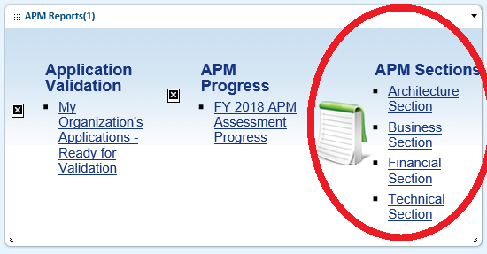
Clicking on the section will present a screen of all available assessments to be filled out, click on the assessment’s tracking ID (left side of the list) to begin.

Part 3: Architecture Section
This is the Architecture section of the assessment. It contains 5 questions. Complete each of these for the application(s) you have been assigned from an Architecture perspective.

Architecture Question Number | Indicator | Question | Response
1 | Architecture Style | What is the primary type of architecture/design for the application? | RADIO BUTTONS:  One-Tier / Monolithic  Two-Tier Client/Server  Three-Tier Component-Based/Modular  N-Tier Service-Oriented  N-Tier Event-Driven
2 | User Interface | What is the primary type of user interface for the application? | RADIO BUTTONS:  Thick/Rich Client  Web Browser-Based  Virtual/Remote Desktop  None
3 | Storage | What is the current size of the database(s) for the application? | RADIO BUTTONS:  <1 GB  1- 99 GB  100-999 GB  1-999 TB  >1 PB
4 | Operations | Who runs the infrastructure and operations for the application? | RADIO BUTTONS:  Internal IT  Software Vendor  External Hosting Provider  Contracted/Managed Services  Cloud
5 | Development | Who develops enhancements and new features for the application? | RADIO BUTTONS:  Internal IT  Software Vendor  External Hosting Provider  Contracted/Managed Services  Cloud

Part 4: Business Section

This is the Business section of the assessment. It contains 15 questions. Please carefully and thoughtfully complete each of these for the application(s) you have been assigned from the Business perspective.

Business Question Number | Indicator | Question | Question Explanation | Response | Response Explanation
1 | Effectiveness | How effective is the application at meeting your business requirements and process needs? | Please consider the degree of fit between currently supported functionality and your business requirements and process needs, and whether functional gaps exist. Additional indicators include the need for ancillary tools such as personal spreadsheets and databases to accomplish tasks. | RADIO BUTTONS:  Label: “5 – Exceptional”, Value: 5  Label: “4 – Highly Effective”, Value: 4  Label: “3 – Effective”, Value: 3  Label: “2 – Somewhat Effective”, Value: 2  Label: “1 – Ineffective”, Value: 1 | 5 – Exceptional: Exceeds all business requirements and process needs; all processes are optimized, no functional gaps exist, and no ancillary tools are needed to complete tasks.  3 – Effective: Sufficiently meets business requirements and process needs; however, some processes are not optimized, some functional gaps exist, or ancillary tools/spreadsheets/databases are necessary to complete tasks.  1 – Ineffective: Does not meet business requirements or process needs; most processes are not optimized, major functional gaps exist, and numerous tools/spreadsheets/databases are critical to complete tasks.
2 | Relevance | How well has the application kept up with change? | Please consider the degree to which functional enhancements have been met in a timely manner, relative to the number of change requests. Additional indicators include relevance to industry/market best practices, processes, and capabilities, and management attention and interest in keeping the application relevant. | RADIO BUTTONS:  Label: “5 – Proactive”, Value: 5  Label: “4 – Very Relevant”, Value: 4  Label: “3 – Relevant”, Value: 3  Label: “2 – Somewhat Relevant”, Value: 2  Label: “1 – Irrelevant”, Value: 1 | 5 – Proactive: Exceptionally responsive and agile; functional enhancements and process needs are proactively addressed; preempts industry/market changes.  3 – Relevant: Remains relevant and has efficiently kept up with changing business requirements, process needs and industry/market capabilities.  1 – Irrelevant: Functionality and processes are out of date; significant enhancements are backlogged or require substantial time and effort to implement.
3 | Complexity | To what extent is the application’s functionality complex, requiring experience and resources to learn, use and manage? | Please consider whether this application is difficult to use, requires specialized expertise, needs significant training, or requires substantial overhead to manage changes, interfaces, and reports. | RADIO BUTTONS:  Label: “5 – Very Simple”, Value: 5  Label: “4 – Simple”, Value: 4  Label: “3 – Reasonable”, Value: 3  Label: “2 – Complex”, Value: 2  Label: “1 – Very Complex”, Value: 1 | 5 - Very Simple: Simple to use, little to no training to learn, and/or does not require specialized resources to manage or to get changes completed.  3 – Reasonable: Reasonable training and expertise to use, some expected attention is required to manage changes, interfaces, and reports.  1 – Very Complex: Difficult to use, very complex, requires significant training and highly specialized resources, significant overhead manage changes, interfaces, and reports.
4 | Utilization | How often is the application utilized and how much business volume is regularly handled by it? | Please consider how often users (including all end-users, managers, administrators) log in to the application (daily, weekly, monthly, yearly) and how rigorously functionality is utilized including process/workflow execution and information access/entry (including both user initiated processes and automated, batch processes). | RADIO BUTTONS:  Label: “5 – Constant”, Value: 5  Label: “4 – Routine”, Value: 4  Label: “3 – Frequent”, Value: 3  Label: “2 – Infrequent”, Value: 2  Label: “1 – Sporadic”, Value: 1 | 5 – Constant: Constant, 24x7 use and/or extremely high volumes of business process transactions/information access  3 – Frequent: Daily or weekly use and/or moderate volumes of business process transactions/information access  1 – Sporadic: Monthly or yearly use and/or low volumes of business process transactions/information access
5 | Usability | How useful, usable, and accessible is the application in meeting business requirements or process needs? | Please consider the interface layout and look and feel (visual design), the ability to quickly navigate, find, and access data (information), the clarity of data validation, error messages, and other points of interaction (interaction design), and the overall reach, understanding, and comprehension with which the user can access and use the application successfully (usability / accessibility). | RADIO BUTTONS:  Label: “5 – Streamlined”, Value: 5  Label: “4 – Intuitive”, Value: 4  Label: “3 – Usable”, Value: 3  Label: “2 – Operable”, Value: 2  Label: “1 – Difficult”, Value: 1 | 5 – Streamlined: The user experience is optimized, information layout corresponds with frequency of use / function importance, interface is well-organized and intuitive; user input is validated and easily correctable; the user interface facilitates intuitive interaction with the application; users find application accessible and desirable to use  3 – Usable: The user interface is generally usable and navigable with minor training; information is usually easy to find; and data and process exceptions are generally understandable and correctable; accessibility issues are minor enough to not detract from overall desirability of the application  1 – Difficult: The user interface is complex; requires substantial training to use; heavy reliance on a few power users to find information; data validation requires translating error codes and exceptions require substantial rework; very little desire to use the application.
6 | Information | How well does the application support your information/data management needs? | Please consider three aspects as to how the application supports the management of information: (1) the integrity and trustworthiness of the data (2) data quality such as searches and reporting accuracy; and (3) whether data are available to employees or customers when they need it. | RADIO BUTTONS:  Label: “5 – Exceptional”, Value: 5  Label: “4 – Excellent”, Value: 4  Label: “3 – Sufficient”, Value: 3  Label: “2 – Tolerable”, Value: 2  Label: “1 – Poor”, Value: 1 | 5 – Exceptional: Information is trustworthy with very high integrity, quality and timeliness. Decisions are confidently made based on information  3 – Sufficient: Information integrity, quality, and timeliness are sufficient; decisions can be made from information, but usually require additional supporting evidence  1 – Poor: Information integrity, quality, and timeliness are poor; no decisions can be based on information due to corruption and volatility.
7 | Security | How well does the application securely protect your information/data? | Please consider enforcement of proper access controls, privacy issues, and regulatory compliance, and how those security controls adversely affect user accessibility, usability, productivity, and effectiveness. | RADIO BUTTONS:  Label: “5 – Optimized”, Value: 5  Label: “4 – Strong”, Value: 4  Label: “3 – Sufficient”, Value: 3  Label: “2 – Vulnerable”, Value: 2  Label: “1 – Exposed”, Value: 1 | 5 – Optimized: All applicable security policies, processes, and procedures are strictly enforced; security controls do not inhibit accessibility, usability, productivity, or effectiveness  3 – Sufficient: Critical security policies, processes, and procedures are enforced; some security controls inhibit accessibility, usability, productivity, or effectiveness; minor security vulnerabilities are known, but acceptable  1 – Exposed: Security policies, processes, and procedures are not properly enforced; known, critical vulnerabilities exist; any existing security controls significantly inhibit accessibility, usability, productivity, and effectiveness
8 | Integration | How well does the application integrate with business processes (and their related data) across different functional areas? | Please consider the ease of process integration, the level of manual intervention (such as repetitive data entry), the timeliness of data updates, and the simplicity of process handoffs. | RADIO BUTTONS:  Label: “5 – Orchestrated”, Value: 5  Label: “4 – Automated”, Value: 4  Label: “3 – Sufficient”, Value: 3  Label: “2 – Manual”, Value: 2  Label: “1 – Disconnected”, Value: 1 | 5 – Orchestrated: Business processes and data are seamlessly and flawlessly integrated in real-time across functional areas; workflows and data translations are choreographed across applications without any manual intervention  3 – Sufficient: Business processes are mostly integrated with automated workflows; some manual rekeying (export/import) necessary for ancillary tools and analysis; data are generally updated in real-time, but some batch and/or manual updates inhibit efficiency  1 – Disconnected: Substantial manual data entry and re-keying across processes; data updates are largely batch and constrain process efficiencies; the application is disconnected from all other applications; data requires substantial translation to adapt with other applications
9 | Resilience | How well does the application function correctly during stressful conditions? | Please consider the robustness of the application in handling high-transaction volume or congested activity, or if the application indicates issues or underlying problems with business process design, data access/entry, technology performance. | RADIO BUTTONS:  Label: “5 – Elastic”, Value: 5  Label: “4 – Very Resilient”, Value: 4  Label: “3 – Resilient”, Value: 3  Label: “2 – Somewhat Resilient”, Value: 2  Label: “1 – Rigid”, Value: 1 | 5 – Elastic: High volume and peak business throughput are handled on demand without failure or service degradation; demand is managed effortlessly without intervention; processes, data, and interfaces are optimized for scale.  3 – Resilient: Minor increases/spikes in volume and throughput without issue; major increases require a reasonable level of management intervention, planning and investment; congestion occurs with an acceptable level of service degradation.  1 – Rigid: Unable to handle increases in volume or throughput without significant service degradation and failure; substantial planning and investment required to meet any increase in demand; process design, data entry and technology are inflexible.
10 | Satisfaction | Please rate your overall satisfaction with the functionality of the application. | Please consider all functional, information, and usage aspects. | RADIO BUTTONS:  Label: “5 – Elated”, Value: 5  Label: “4 – Very Satisfied”, Value: 4  Label: “3 – Satisfied”, Value: 3  Label: “2 – Somewhat Satisfied”, Value: 2  Label: “1 – Unsatisfied”, Value: 1 | 5 – Elated: Exceeds expectations; directly improves business performance; optimal business process automation; measurably increases data quality and accessibility.  3 – Satisfied: Meets expectations; indirectly improves business performance; acceptable level of business process automation; sustains and improves data quality and accessibility.  1 – Unsatisfied: Does not meet expectations; degrades business performance; impedes business processes; degrades data quality and accessibility.
11 | Change Rate | For the business processes that the application supports, how frequently do those business processes change? | Please consider the broader environment surrounding the business processes including business strategy adjustments, regulatory updates, and economic impacts as well as operational changes. | RADIO BUTTONS:  Label: “Stable”, Value: 1  Label: “Recurrent”, Value: 2  Label: “Unpredictable”, Value: 3 | Stable: The business processes are formally structured and stable with a high degree of standardization, repeatability and control. Changes to the processes are rare and infrequent.  Recurrent: The business processes are defined with regular/periodic change in response to competitive pressures for differentiation. Processes are configurable and must adapt quickly even though change is minimized.  Unpredictable: The business processes change frequently in response to dynamic and unknown business conditions. Processes are exploratory and innovative with continual change.
12 | Engagement | How are the business sponsors, stakeholders and users engaged in managing the application? | Please consider how the business and IT work together to plan, implement, and maintain the application. | RADIO BUTTONS:  Label: “Formal Process”, Value: 1  Label: “Part of the Team”, Value: 2  Label: “Doing the Work”, Value: 3 | Formal Process: There is a formal process for engaging IT and business sponsors, stakeholders and users throughout the life cycle of the application. Clear scope and objectives are defined for each interaction.  Part of the Team: IT and business sponsors, stakeholders and users are part of the project team and collaboratively manage the application throughout its life cycle. Interactions are fluid and sometimes spontaneous.  Doing the Work: Business power users manage the application directly with IT throughout its life cycle to stay close to the ideas and implementation.
13 | Competitiveness | How does the application contribute to the business strategy? | Please consider whether the application contributes to the business' competitive advantage or if the application is a cost of doing business. | RADIO BUTTONS:  Label: “Enable Cost Effective Scale”, Value: 1  Label: “Sustain Competitive Advantage”, Value: 2  Label: “Create Competitive Advantage”, Value: 3 | Enable Cost Effective Scale: The application supports commodity technology and scales well-defined capabilities.  Sustain Competitive Advantage: The application improves on existing ideas, enables unique capabilities, and sustains differentiation.  Create Competitive Advantage: The application enables innovative ideas, new ventures, and emerging trends.
14 | Duplicate | Is there another application currently in use that performs the same function? |  | RADIO BUTTONS:  Label: “Yes”, Value: 0  Label: “No”, Value: 1
15 | Organization | Does the application serve users within one department only? |  | RADIO BUTTONS:  Text: “Yes”, Value: 0  Text: “No”, Value: 1

Part 5: Financial Section
This is the Financial section of the assessment. It contains 3 questions. Please carefully and thoughtfully complete each of these for the application(s) you have been assigned from a Financial perspective.

Financial Question Number | Indicator | Question | Question Explanation | Response | Response Explanation
1 | Support Costs | What is the estimated annual support cost required to maintain and run the application? | For the 2017 fiscal year, please consider the labor and services costs required for:  - Routine maintenance and support, break / fix, patch and upgrade (internal and contracted)  - Shared support that can be reasonably allocated to this application (e.g., service desk, monitoring, deployment)  - Hardware and infrastructure support that can be reasonably allocated to this application  - FTE support, which may include State employees, contractors and/or consultants  Please do not include costs required for application enhancements.  Please select the appropriate dollar range from the options provided. | RADIO BUTTONS:  $0 - $25,000  $25,001 - $100,000  $100,001 - $250,000  $250,001 - $500,000  $500,001 - $1,000,000  $1,000,001 - $5,000,000  Greater than $5,000,000
2 | Licenses | What are the annual hardware maintenance and software license fees for the application? | For the 2017 fiscal year, please consider all on-going annual hardware maintenance and software license fees. These fees include: application software, application server, database server, and other infrastructure that can be reasonably allocated to this application.  Please only include annual recurring license costs. Do not include onetime “sunk costs” related to this application’s licenses(e.g. initial license fees).  Please do not include initial license fees, client hardware licenses or network telephony that have negligible impact. Select the appropriate dollar range from the options provided. | RADIO BUTTONS:  Less than $5,000  $5,001 - $10,000  $10,001 - $25,000  $25,001 - $100,000  $100,001 - $200,000  $200,001 - $500,000  $500,001 - $1,000,000  Greater than $1,000,000
3 | Remediation Costs | Identify whether remediation costs have been identified and documented. | Cost components of remediation cost estimates may include: new hardware, new software, re-factoring, architecture design, development, deployment, changes to workforce, etc. | RADIO BUTTONS:  Label: “Yes”, Value: 0  Label: “No”, Value: 1

Part 6: Technical Section
This is the Technical section of the assessment. It contains 10 questions. Please carefully and thoughtfully complete each of these for the application(s) you have been assigned from the Technical perspective.
Technical Question Number | Indicator | Question | Question Explanation | Response | Response Explanation
1 | Standards | How well does the application align with accepted architecture practices, development principles and technology standards? | Please consider whether the application supports the architectural direction of the organization such as service oriented architecture (SOA), business process management (BPM) and master data management (MDM); adherence to design principles such as loose coupling and modular design; and alignment with standardized technology platforms, infrastructure, and vendors. | RADIO BUTTONS:  Label: “5 – Exemplary”, Value: 5  Label: “4 – Well Aligned”, Value: 4  Label: “3 – Aligned”, Value: 3  Label: “2 – Somewhat Aligned”, Value: 2  Label: “1 – Not Compliant”, Value: 1 | 5 – Exemplary: A model that demonstrates the architectural direction; implementation of all design principles; uses all standardized platforms, infrastructure, and vendors.  3 – Aligned: Compatible with most current practices, principles and standards (or work is under way that will render it so); waivers or rationale for non-compliance are documented and justifiable.  1 – Not Compliant: Incompatible with current practices, principles and standards without reasonable justification (and lacking intention of increasing alignment)
2 | Extensibility | How easily does the application adapt to changes and extend to meet new requirements? | Please consider the degree to which changes are easily and responsively made to design, construction, integration and implementation of the application including:  q Addition of business functionality.  q Addition, deletion or modification of interfaces and integration to/from other applications.  q Adaptation to infrastructure changes.  q Collaborative interaction with external applications or services.  q Evolution to new development languages and methods. | RADIO BUTTONS:  Label: “5 – Model-Driven”, Value: 5  Label: “4 – Very Configurable”, Value: 4  Label: “3 – Configurable”, Value: 3  Label: “2 – Somewhat Configurable”, Value: 2  Label: “1 – Programmatic”, Value: 1 | 5 - Model-Driven – Graphical, drag-n-drop technical adaptation and functional extensibility. Marginal effort needed to achieve additional capability and to sustain application relevancy.  3 – Configurable: Configurations enable responsive to most functional enhancements; technologies are reasonably adaptive with the exception of known core dependencies; extensibility is achieved through configuration and additional modules.  1 – Programmatic: Difficult and costly to extend functionality to any degree without significant modernization, programming, and database changes; technologies are unchangeable without significant investments;
3 | Scalability | How easily does the application scale to deliver additional capacity? | Please consider the degree to which the application responds to additional demand including growth in the number of users, usage, and data volume. | RADIO BUTTONS:  Label: “5 – Elastic”, Value: 5  Label: “4 – Very Scalable”, Value: 4  Label: “3 – Scalable”, Value: 3  Label: “2 – Somewhat Scalable”, Value: 2  Label: “1 – Rigid”, Value: 1 | 5 - Elastic – On demand technical scalability and capacity. Marginal effort needed to achieve growth and sustain application relevancy.  3 – Scalable: Responsive to most demand growth. Technologies are reasonably adaptive with the exception of known core dependencies; increases in scale and capacity are achievable, but not without advanced planning and investment.  1 – Rigid: Difficult and costly to scale to any degree; technologies are unchangeable without significant modernization investments; increases in scale and capacity are unachievable without significant changes to software and hardware.
4 | Integration | How easily does the application integrate data and processes? | Please consider the efficiency of both data (e.g., batch, ETL) and process (e.g., real-time, Web Services) integrations; the ease with which integration can be changed to reflect changing business processes; the degree to which data translations, technology adapters, and interfaces are hard-coded within the application or abstracted into integration hubs. | RADIO BUTTONS:  Label: “5 – Orchestrated”, Value: 5  Label: “4 – Automated”, Value: 4  Label: “3 – Sufficient”, Value: 3  Label: “2 – Manual”, Value: 2  Label: “1 – Disconnected”, Value: 1 | 5 – Orchestrated: Business processes and data are choreographed through an enterprise service bus or integration hub without manual intervention; interfaces adhere to standards for simplicity; connectors are adapted for modularity and efficient change; data translations are mapped for configurability.  3 – Sufficient: Critical business processes are integrated with automated workflows; point-to-point integration is the primary integration mechanism; ancillary business processes require some manual rekeying (export/import); data are generally updated in real-time, but some delayed batch and/or manual updates exist.  1 – Disconnected: Applications are siloed and compartmentalized; substantial manual data entry and re-keying with minimal integration; data updates are largely batch and constrain process efficiencies; data requires substantial, mostly manual translation to adapt with other applications
5 | Security | How robust are the security controls for the application? | Please consider integration with enterprise identity management databases including integration with single sign-on; enforcement of required credentials across all user and system roles; adherence to role-based access control or other regulated authorization; the use of penetration, injection, and other dynamic/static security tests. | RADIO BUTTONS:  Label: “5 – Optimized”, Value: 5  Label: “4 – Strong”, Value: 4  Label: “3 – Sufficient”, Value: 3  Label: “2 – Vulnerable”, Value: 2  Label: “1 – Exposed”, Value: 1 | 5 – Optimized: Participates in enterprise identity management; enforces all credential requirements and policies; properly implements role-based access control; passes all security tests; actively logs and monitors activity with event-based notifications  3 – Sufficient: Contains an internal identity database that adheres to enterprise identity policies; requires strong passwords, but does not support more secure credentials; maintains good access control and separation of data; passes most security tests with known and tracked vulnerabilities, logs critical activity  1 – Exposed: Does not enforce any enterprise security controls; data is accessible and visible to anyone; fails most security tests or is consistently found in violation; no activity logging or monitoring.
6 | Recovery | What assurances are in place to recover the application in the event of a disruption or disaster? | Please consider redundancy in hardware and software platforms, physical locations of data centers, frequency and comprehensiveness of replication, global and local failover, specificity of recovery time and point objectives, and the frequency and success of disaster recovery exercises. | RADIO BUTTONS:  Label: “5 – Full”, Value: 5  Label: “4 – Most”, Value: 4  Label: “3 – Sufficient”, Value: 3  Label: “2 – Insufficient”, Value: 2  Label: “1 – None”, Value: 1 | 5 – Full: Business continuity is fully implemented including physically separate, redundant environments, replication, and clustering/grid failover as necessary; disaster recovery exercises consistently meet or exceed recovery time and point objectives  3 – Sufficient: Impacts of data loss are generally understood; some redundancy exists for critical processes and data, but most loss is acceptable or recoverable given time; disaster recovery exercises are conducted periodically with known and acceptable deficiencies  1 – None: Impacts of loss are not understood; no redundancy or recoverability; in the event of a disaster, all assets are lost.
7 | Analytics | What type of analytics is performed with the application? | Please consider the primary usage of information from the application | RADIO BUTTONS:  Label: “Describing”, Value: 1  Label: “Planning”, Value: 2  Label: "Predicting", Value: 3 | Describing: Primarily operational and historical reports that describe past events  Planning: Primarily operational and business activity events that assist with future planning and budgeting  Predicting: Primarily scenario-based data mining and analysis that identify trends and potential behaviors
8 | Users | Is the number of users for the application less than 50? |  | RADIO BUTTONS:  Label: “Yes”, Value: 0  Label: “No”, Value: 1
9 | Specialization | Do the application require specialized skills or unique expertise to maintain? |  | RADIO BUTTONS:  Label: “Yes”, Value: 0  Label: “No”, Value: 1
10 | Security | Please identify which (if any) of these security risks are applicable. | It is expected per TAC 202 requirements, that agencies have assessed the security posture of their software and hardware environments. As a result of these reviews, agencies should have identified various security risks exposed by any system in their environment. | CHECK BOXES (select one or several):  - Software security fixes are no longer available from the manufacturer, or cannot be applied due to compatibility constraints in the current environment.  - Software lacks support for encrypted transport.  - Lack of effective modern Authentication, Authorization and Accounting (AAA) mechanisms.  - Forced to use old security protocols or configurations within the security infrastructure; which introduces legacy risks to new systems.  - Hardware is easily impacted by Denial of Service (DoS) attacks due to limited performance.  - Hardware is unable to support the necessary modern secure software systems.  - None

Glossary
Assessment. A collection of Indicators (Questions and Ratings) for each Business Application to be filled out by Respondents.
Business Application. A Business Application name is the high-level label used by an agency business and IT organization to easily identify a group of functions provided by one or more systems to accomplish the specific business needs of the agency. A Business Application is typically a combination of integrated hardware and software (including data and applications), internally developed custom systems, commercial off the shelf (COTS) applications, and/or customized third-party systems.

Assessors. The person or people who rate each Business Application by completing a questionnaire.

Reviewers. The person or people who review each assessment section performed by assessors.

APM Coordinator. The person at the agency organizing the APM assessment of the Business Application by assigning assessors and reviewers.

